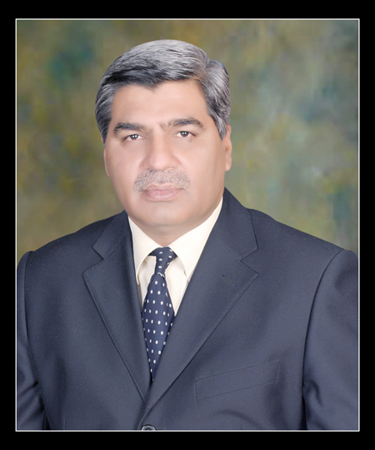
Muhammad Afzal Sipra

243-A, R.E.C.H.S Johar Town, Lahore - Pakistan. Cell Nos., 0092(0)3225200003 Skype: muhammadafzalsipra1

e-mail: muhammadafzalsipra@hotmail.com;
muhammadafzalsipra@yahoo.com; mafzalsipra@gmail.com

Strengths:

22-years blend of experience in fields of Teaching, educational Management and its applications in practical field. During this tenure, I taught the subjects of commerce and business studies to the Graduate and Post-Graduate classes (BBA, B.Com, MBA, M.Com). Development of Course Curriculum, Academic Code of Conduct, teaching strategies of faculties were also major part of my experience. I also served as Head of Examiner.

I with my team launched new educational institutions by formulating feasibility reports and qualifying legalities with Boards and Universities like Registrations and Affiliation. The conversion, up-gradation, promotion and institutional advancement of 19- PR schools in English Medium from Urdu Medium in intra and inter cities of Pakistan were also another challenging task which I did.

I being Regional and Project Manager, Managed the projects at National and International level Punjab-Pakistan and with IOM under USAID/ CHEF in Afghanistan.

Head of Services & Projects
1st September 2013 onward

Planning , executing and managing the HVAC projects

September 2006 to 31st August 2013

- September 2006 to 31st August 2013

Regional Manager (Central 1 &11-Punjab)
Sabro Services; Sabro Technologies (Pvt) Ltd; S.A Brothers (Pvt) Ltd

Duties & Responsibilities:
- Management of after sale services for commercial and residential HVAC to a very wide network in Punjab-Pakistan and Afghanistan.
- Managed the surveys, assessments, viabilities of Educational; Hospitals Telecommunication Industries, and other commercial Organizations.

Some of major HVAC projects are as Under:

1. Beaconhouse National University (BNU. 2. Pakistan School of Fashion Design.
3. Pakistan telecommunication (Pvt) Ltd. 4. Federal Board of Revenue (FBR).
5. Mobilink Telecom Pakistan. 6. World Call Telecom Lahore.
7. Government Hospitals. 8. ZTE (Chinese Company)
9. National Logistic Cell (Govt Colleges in Punjab-NLC).
10.Project Manager of 100 Bed Gardez Hospital under IOM, USAID, CHEF in
Afghanistan.
11. JDW –United Sugar Mills Ltd-Unit-11; Machi Gote Sadiqabad
12 JDW –Ghotki Sugar Mills Ltd Sind (continue)

- November 2001 to September 2006:

Manager Business Development in Beaconhouse Group.

6- Years experience in educational development with ESL-PR Project consists of 19 Schools of Pakistan Railways in different cities in Pakistan. I performed the responsibilities of admission, curriculum, promotional and institutional advancement. Registrations, affiliations and examination matters with concerned Government Educational Departments was also part of my duties.

Launched, 02 Colleges named as AXIS College for Boys and Girls in addition to the schools.On termination of agreement between the management of the Beaconhouse Group and Pakistan Railway. I was transferred to the project HPS(Hire Purchase Solution)for planning and execution.

- April 2000 to November 2001

General Manager in Graduate School of Management and Computer Science-TIU

Being General Manager of TIU letter of Appreciation for dedication, devotion and better management /Administration was awarded me by the worthy President of GSC &CS (TIU) Mr. Khurram Nawaz Khan.

- July 1998 to January 25, 2000

Associate Dean /Principal in the Minhaj Colleges -The Minhaj University

Launched the Project of Education from Intermediate to Master Degree Programmes successfully with 1500 students body. Get it qualified the Registrations and affiliations by the concerned educational Boards /University .
Designed the Study’s code of conducts, promotional campaigns, co and Extra curricular activities. I was also member of decision making body -CMC(Central mass Committee ) . I also taught the business subjects to master classes.

- Nov. 1996 to June 1998

Administrative and Operational Head in Lawrence Institute of Management Sciences

The institute is presently known as Pak Lawrence Institute which was a sick educational unit it was developed (lifted up) from 29 to 513 students. I managed the Academics and Promotional Mix with legal recognition of Govt, educational Departments.

I had also taught the subject to BBA and MBA classes. Designing of the Course curriculum and educational conducts was also one of the major parts of my responsibilities.

- October 1991 to November 1995

Permanent Faculty Member in The International University (TIU)

The International University-TIU(Graduate School of Management and Computer Sciences) firstly I worked as permanent Faculty Member where I taught business subject to MBA and BBA Classess .

- Sept 1990 to Oct 1991

Marketing Manager in S.A Hameed & Sons(Bergman Laboratories)
May Flower Chemical Company), Prince Cosmetics company (Regd)
Being Marketing Manager I increased 40% sales volume of products covering Lahore, Karachi Faisalabad.

Education:

1990 -M.Com Master in commerce, Major in Marketing, Hailey College of
Commerce,Punjab University, Lahore- Pakistan.

1996 -MBA Master in business Administration, Major in Finance, Lawrence
Institute of management Sciences, Lahore- Pakistan.

1987 - B.Com Govt. Islamia College of Commerce, Punjab University, Lahore-Pakistan

Certificates:
- Certification in Advertising and Sales Promotion from Pakistan Institute of Management Sciences PIMS) Gulberg, Lahore. Govt. of the Punjab.
- Certificate in Export Procedure and Promotion from IBP, Lahore.
- Certificate in Software Applications from UET, Lahore
- Certificate in Oracle-7 + Developer 2000 from UET Lahore

Computer Skills: Hands on Experience in Microsoft office, Internet.
Note: I had also completed some special educational assignments awarded by the Technical Board Lahore, University of Azad Jammun and Kashmir, Allama Iqbal Open University.

